SERIES AND PARALLEL CIRCUITS

There are two basic arrangements of components in a circuit.

Series Circuits

The resistors are added end-to-end so that the whole current flows through each resistor in turn.

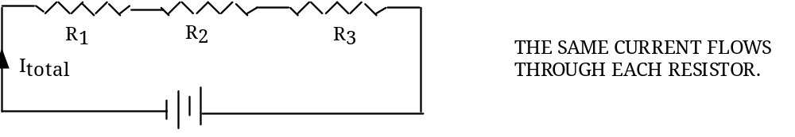

• There is only one path for the current through the circuit.
• If one component stops working, they all stop working.
• Resistance increases with more components added.

Parallel Circuits

The resistors are on separate branches, and the current splits up to flow through each branch, depending on its resistance.

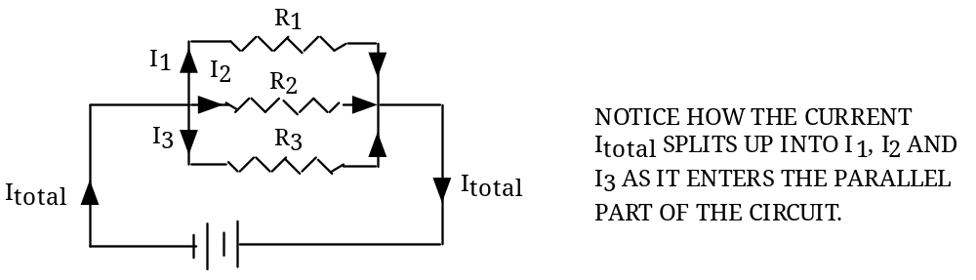

• Current splits up - there are multiple pathways.
• If one component is turned off, the others keep working.
• Resistance decreases for more and more resistors connected in parallel.

